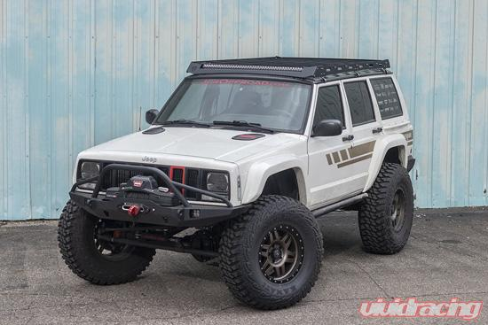**Week 2.4:**

Continue to use the system you chose and further analyze the nameplate data or technical specifications for it. It may be necessary to use both nameplate data and technical specifications if your system has both. Include a picture of your system and its technical specifications or nameplate in your document. Create a word document that presents this information and then answers the following questions:

**The state of the vehicle is: Running 10-20mph “lights and radio off”**

* What type of eclectic motor is used in your system?

**DC**

* Does the electric motor in your system match the input power type, i.e. DC, AC, 3Ph AC? If not, what is used to change the power type to run the motor?

**3Ph AC Diodes are used for current flow direction and a voltage regulator is used for the level and timing of voltage.**

* How much power is the electric motor in your system rated for?

**800W**

* What percentage of the total system power (found in electrical systems “week 1”) does this motor consume?

**About 80% the other 20% is used for managing the engine.**